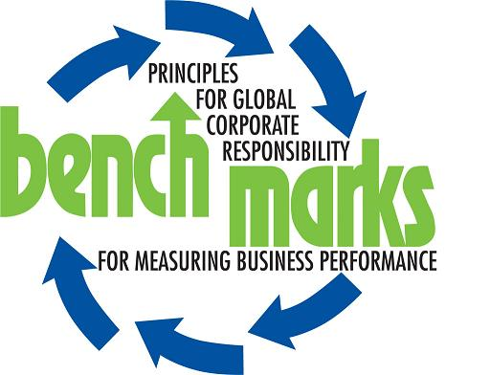
Media statement by Bench Marks Southern Africa for Corporate Social Responsibility
Embargoed for release: 10H00: Monday: 25th June 2007
_______________________________________________________________
Platinum mines lack transparency, communities suffer
Communities in the platinum mining industry region of the North West Province of South Africa are getting short changed in transformation initiatives by the mines concerned, according to John Capel, Executive Director of The Bench Marks Foundation of Southern Africa for Corporate Social Responsibility.
In a study done by The Bench Marks Foundation on the Corporate Social Responsibility programmes of the platinum mining companies in the North West, inadequacies in respect of health, labour, transformation, environmental effects as well as safety are severely criticised.
Although platinum mining in the region is damaging the environment, increasing the numbers of respiratory infections of people in the area and contributing to the numbers of informal settlements, all is not lost - for the study highlights areas in which communities can benefit from the boom in platinum mining.
“Our study recommends ways in which the mines, the community and the government can work together in order to address some of the issues identified. Many of the suggestions tackle ways in which the damage to the environment can be mitigated and turned into income generating ventures for the community,” Capel explains.
One such project is reed and grass production and harvesting. This would tackle mine waste rehabilitation by absorbing the impurities from the polluted water. Communities would be able to manufacture products from the reeds and earn an income from their sales.
Another project is pomegranate and vegetable juice production as part of mine waste rehabilitation and use of under-utilised land. Pomegranate juice and vegetable juices are in high demand in the food, organic medicines and pharmaceutical industries. Pomegranates grow well on marginal soils, even on the soil of tailings facilities; this would provide employment and income for the communities.
An area of concern identified by the study is the lack of capacity at local and provincial government levels to independently monitor the impact of mining on surface water and air quality. This issue needs to be addressed by the government and monitored by non-governmental agencies, faith based organisations and the communities, according to Capel.
Another recommendation by the Bench Marks Foundation is that there should be transparency in the reporting by mines on dewatering and pumping out of underground water contained in aquivers, the pollution of underground water and on the perforation of dykes.
The study also discovered that the disabled are excluded from any policies for employment even though mining activities contributes to the majority of disabled cases. The Foundation says that the mining policies must be revised to include the disabled by offering employment and health benefits.
“Mine workers employed by sub-contractors are not considered as employees of the mining corporations. They are excluded from training development, advancement opportunities and health benefits,” says Capel. “This creates tension between the various factions within the mines.”
The living out allowance given to workers by the mines is another area that also needs to be rectified. At present, this allows for mine workers to live outside the mines in surrounding towns and has resulted in a flood of mostly ‘foreign’ (South Africans from provinces other than the North West and non-South Africans) workers into these areas. Due to an already long waiting list for housing, locals are often in conflict with foreign mine workers, resulting in xenophobia, vigilantism, mob violence and crime.
Although the mining corporations seem to be aware of the impact of HIV/AIDS on their workers and their dependants, they ignore the impact that the policies of migrant labour, sub-contracting, living out allowance and the lack of job opportunities for women (who then engage in sex services to earn a living) has on the health of the community. By just curing symptoms or approaching selected causes, the overall health situation in Rustenburg cannot be significantly improved.
But by implementing some of the recommendations made in the study, the cumulative effects of the increase in platinum production in the North West Province can be reduced and the communities, who have not benefited through the platinum boom in the past, can begin to do so.
ENDS
The full report together with all the recommendations and photographs can be found on:
www.bench-marks.org.

Bench Marks Foundation Southern Africa (The Bench Marks Foundation) is part of an international NGO and Faith Based coalition that also has partners in Australia, Hong Kong, Canada, the USA, Colombia and the United Kingdom. Its partners in South Africa are the SA Council of Churches, the Ecumenical Service for Socio-Economic Transformation (ESSET), Industrial Mission of South Africa, and the Justice and Peace Department of the South African Catholic Bishops Conference. The Bench Marks Foundation is committed to providing leadership and advocacy on issues regarding benchmarking of good corporate governance, ethical and socially responsible investment as well as linking people and institutions committed to these ideals.
______________________________________________________________
Issued by Quo Vadis Communications on behalf of Bench Marks Foundation of Southern Africa.
QUO VADIS COMMUNICATIONS AND ITS STAFF MAY NOT BE QUOTED ON BEHALF OF BENCH MARKS
Media contact: Chantal Meugens
Cell: 083 676 2294 or 011 955 5033 or 011 487 0026
E-mail: chantal@quo-vadis.co.za

Client contact: John Capel, Executive Director, Bench Marks Foundation Southern Africa
Cell: 082 874 2653
Tel: 011 832 1743

